**OUTPUTS:**

1)Open the terminal in the VS code and type the command

” python manage.py runserver”.

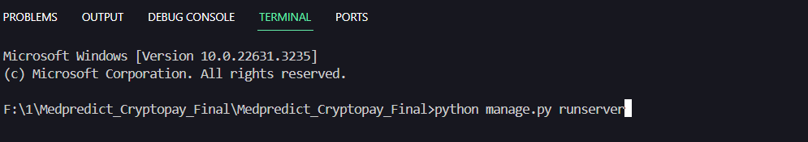

2)Now click on the generated link

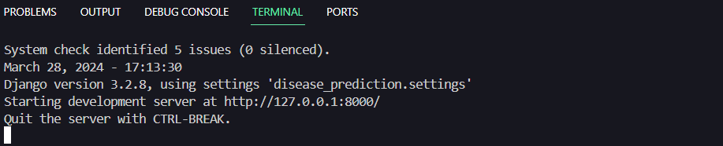

3)The website will open in the browser

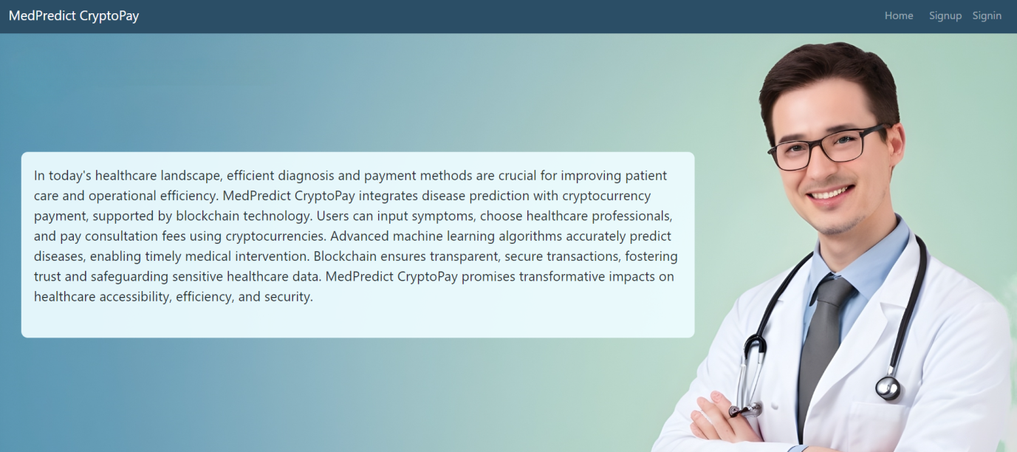

4)Doctor and Patitent can signup

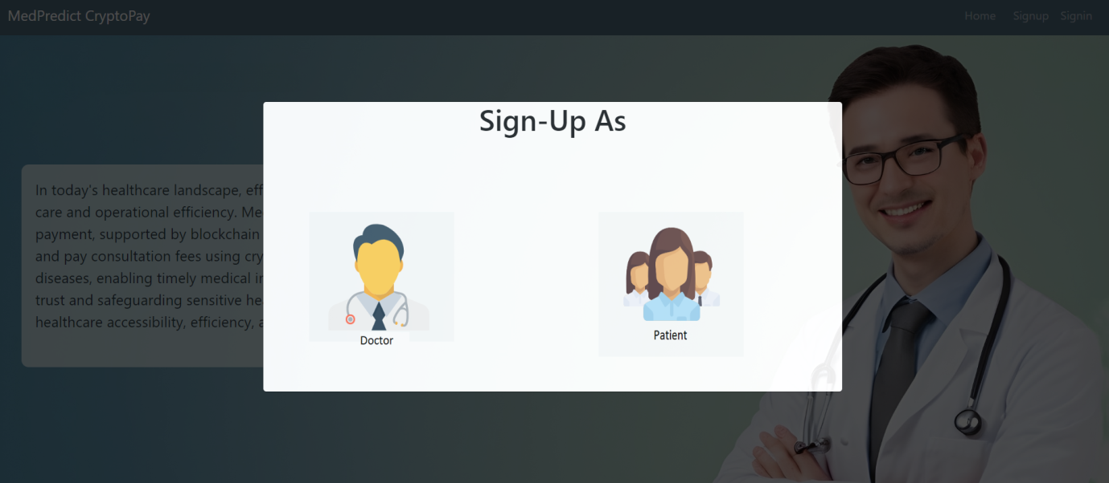

5)Admin,Doctor and Patitent can signin

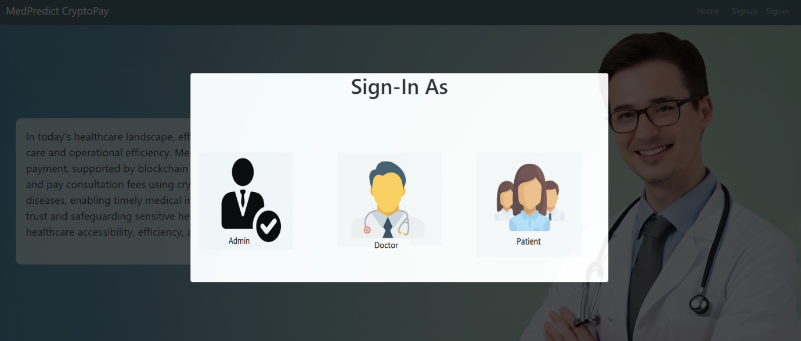

6)After patitent authentication,the patient can check for disease and view previous consultation history

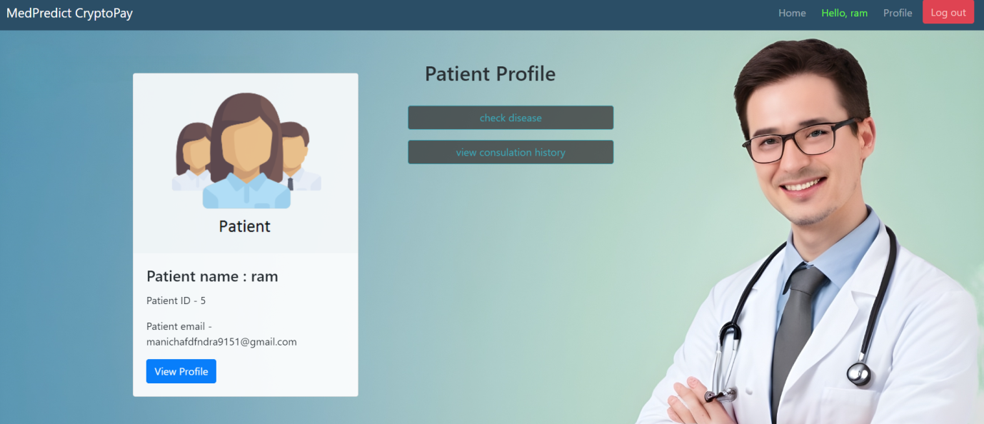

7)In check disease functionality ,the patient can add symptoms

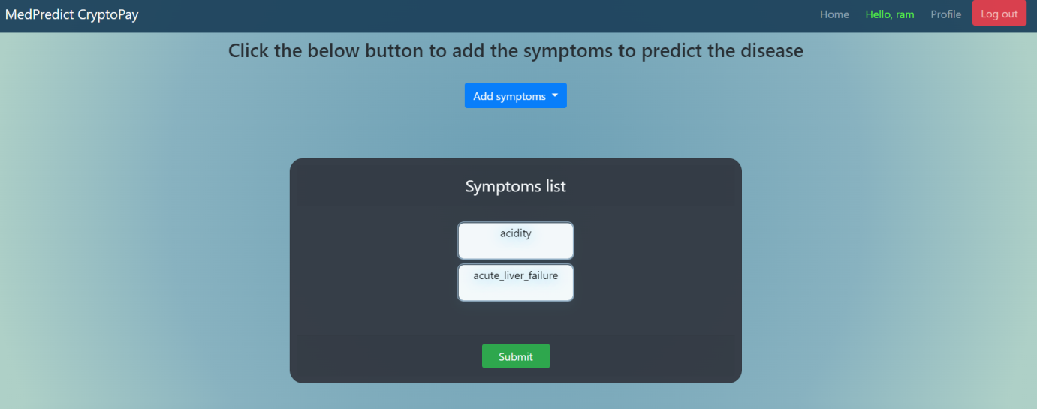

8)After adding symptoms ,patient can consult the suggested doctor or can consult from all the available doctors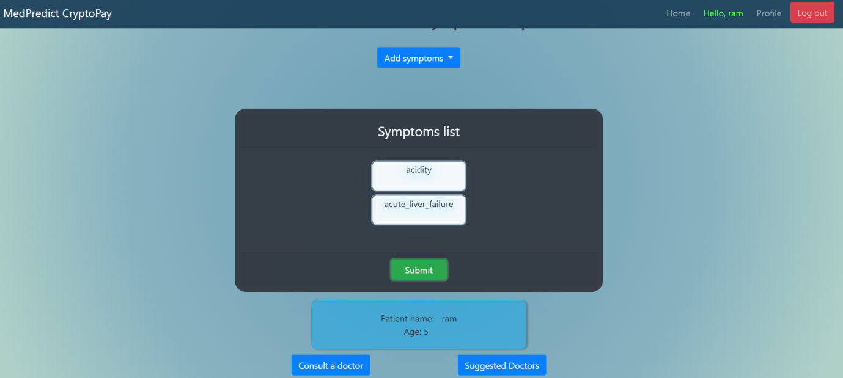

9)Patient has to pay the doctor fee for the consultation

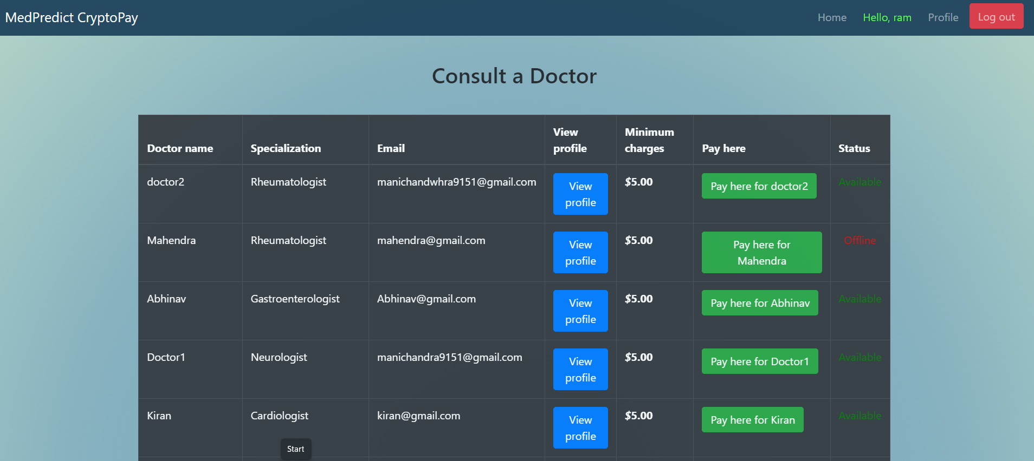

10)Pay button redirects to coinbase

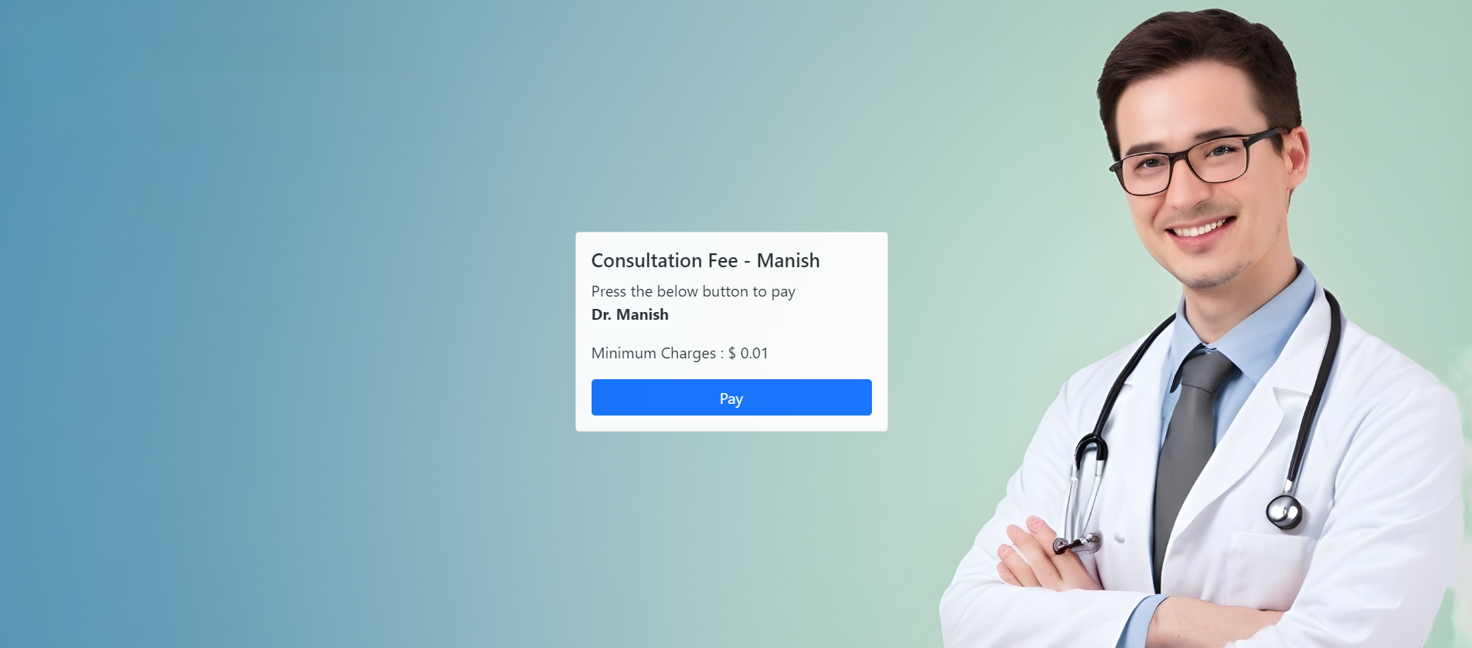

11)Patient has to connect the wallet for payment

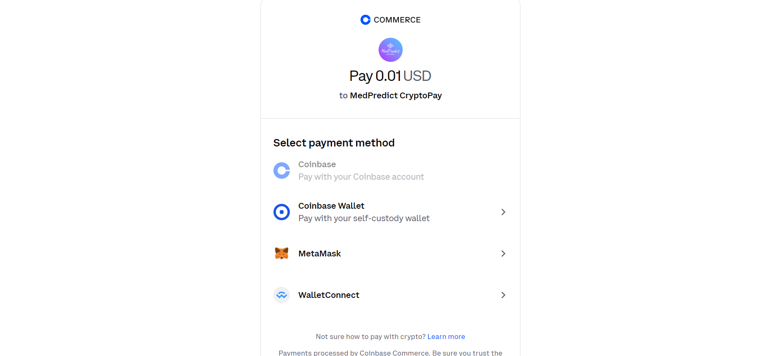

12)After payment ,chat window will be accessible for communication between doctor and patient

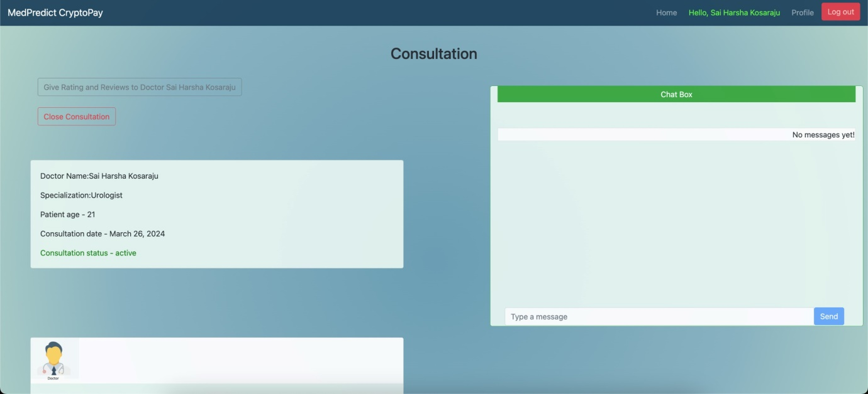

13)After doctor authentication ,doctor can appear offline/online and can view consultation history

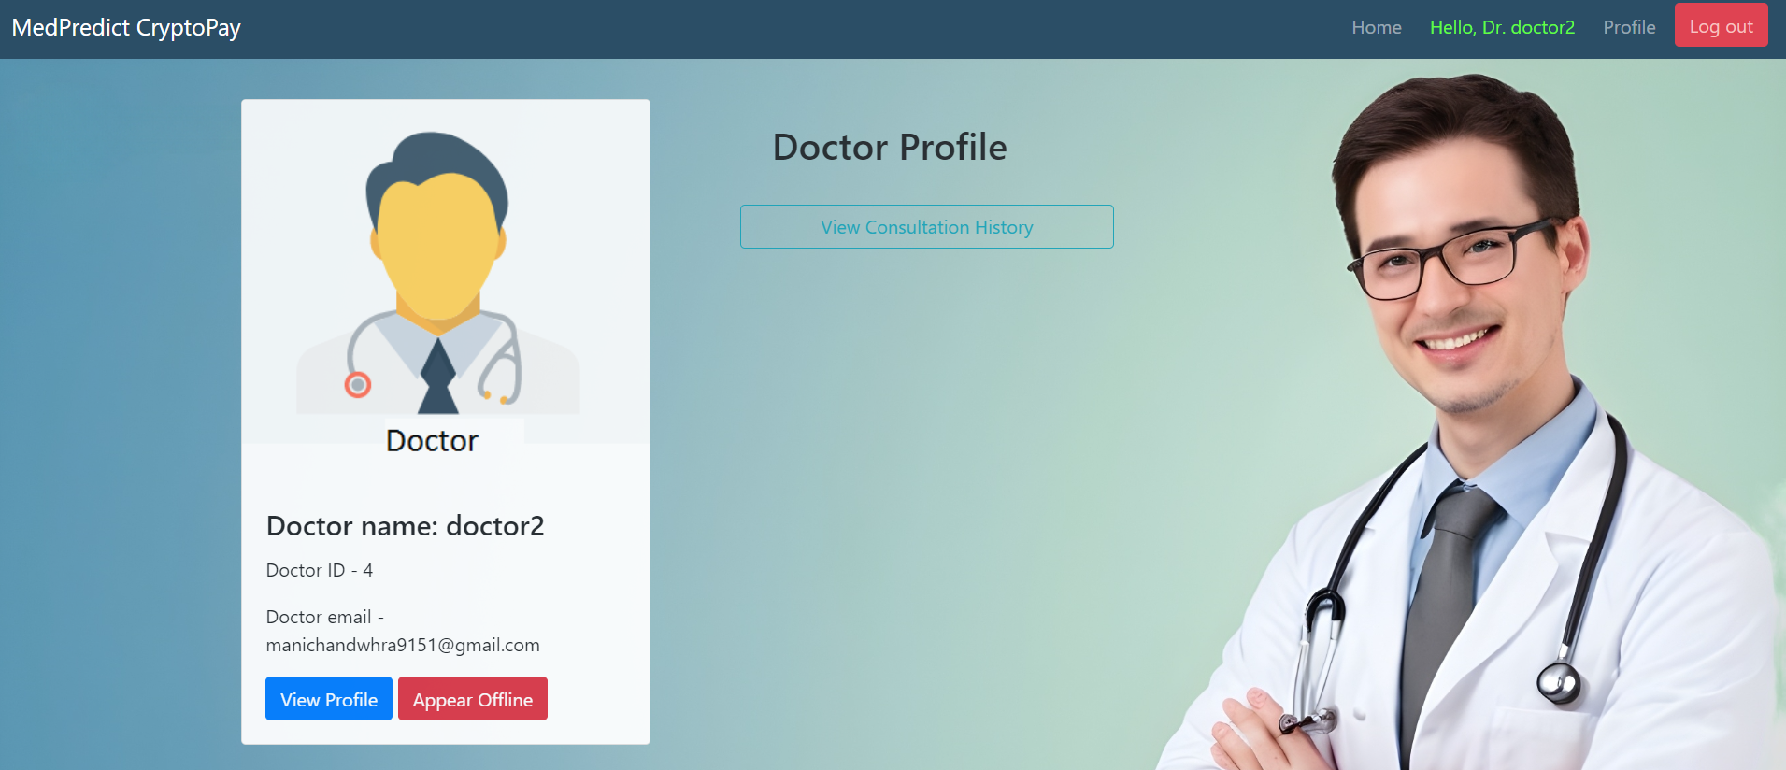

14)Doctor can consult patients

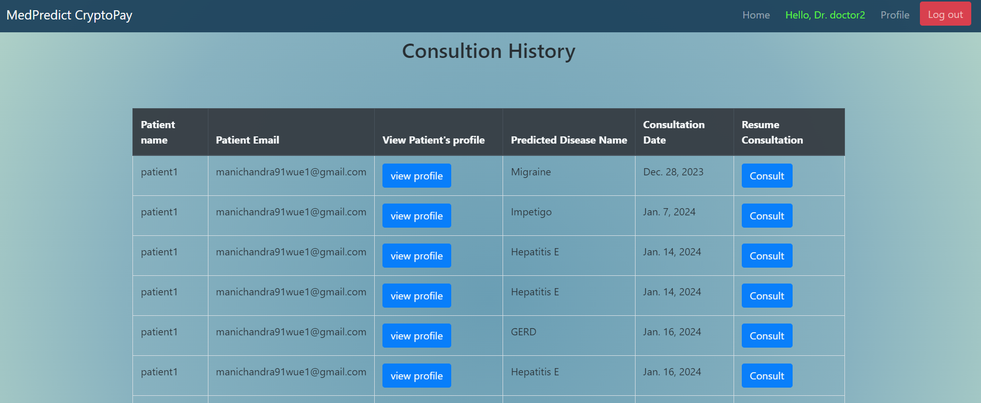

15)Consultation happens through the chat window and after consultation ,doctor can close the consultation.

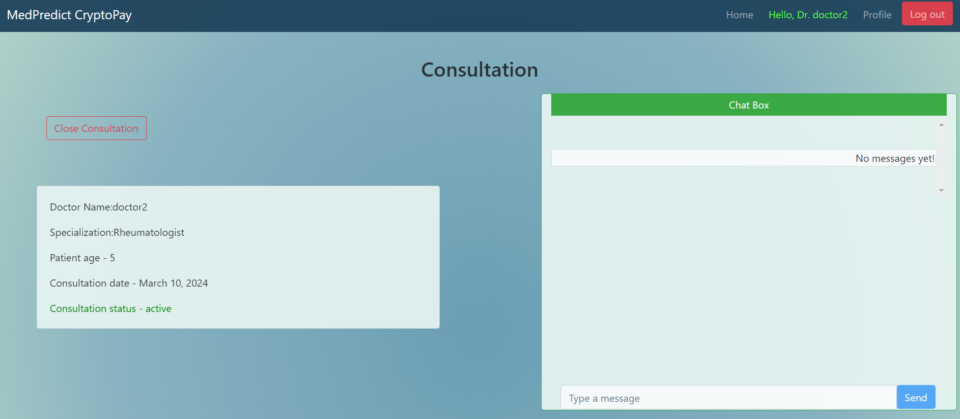

16)On payment page,patient has to connect their respective metamask wallet to proceed with the payment process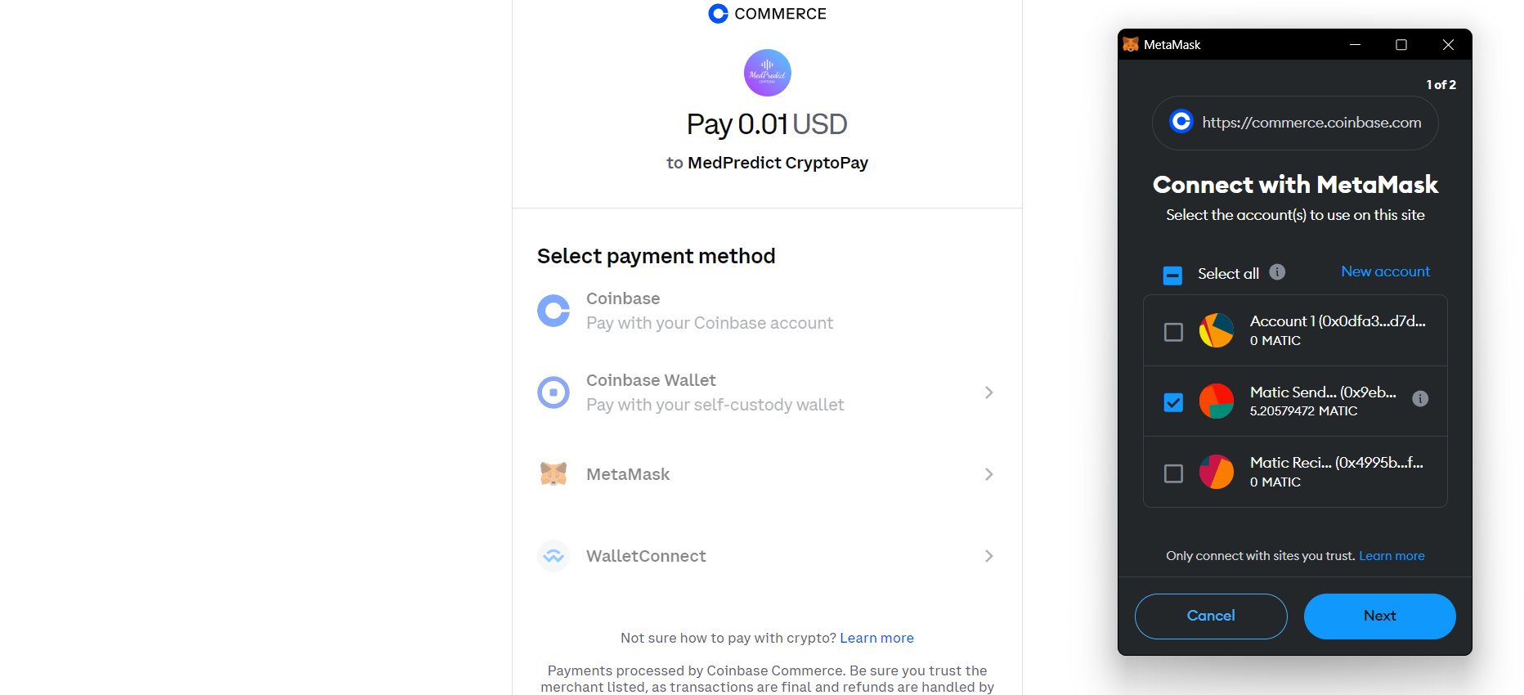

17)Once the payment is done,Doctor can view the payment status as completed in the coinbase payments window.

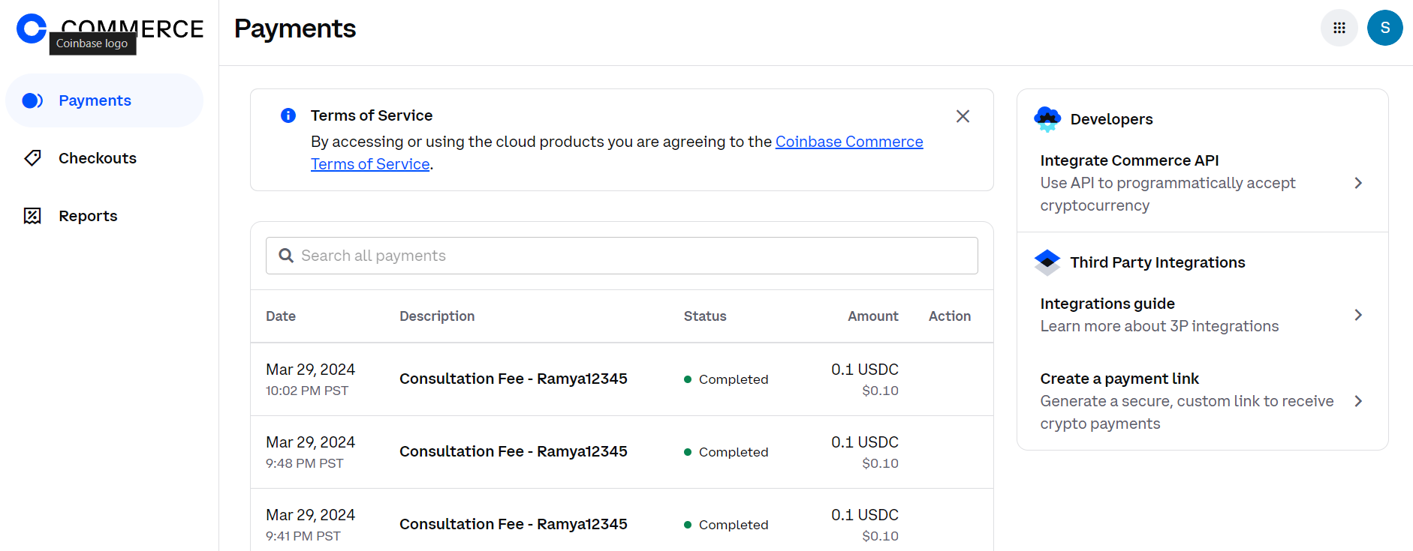

18)Doctor has all the information regarding the payment done by the patient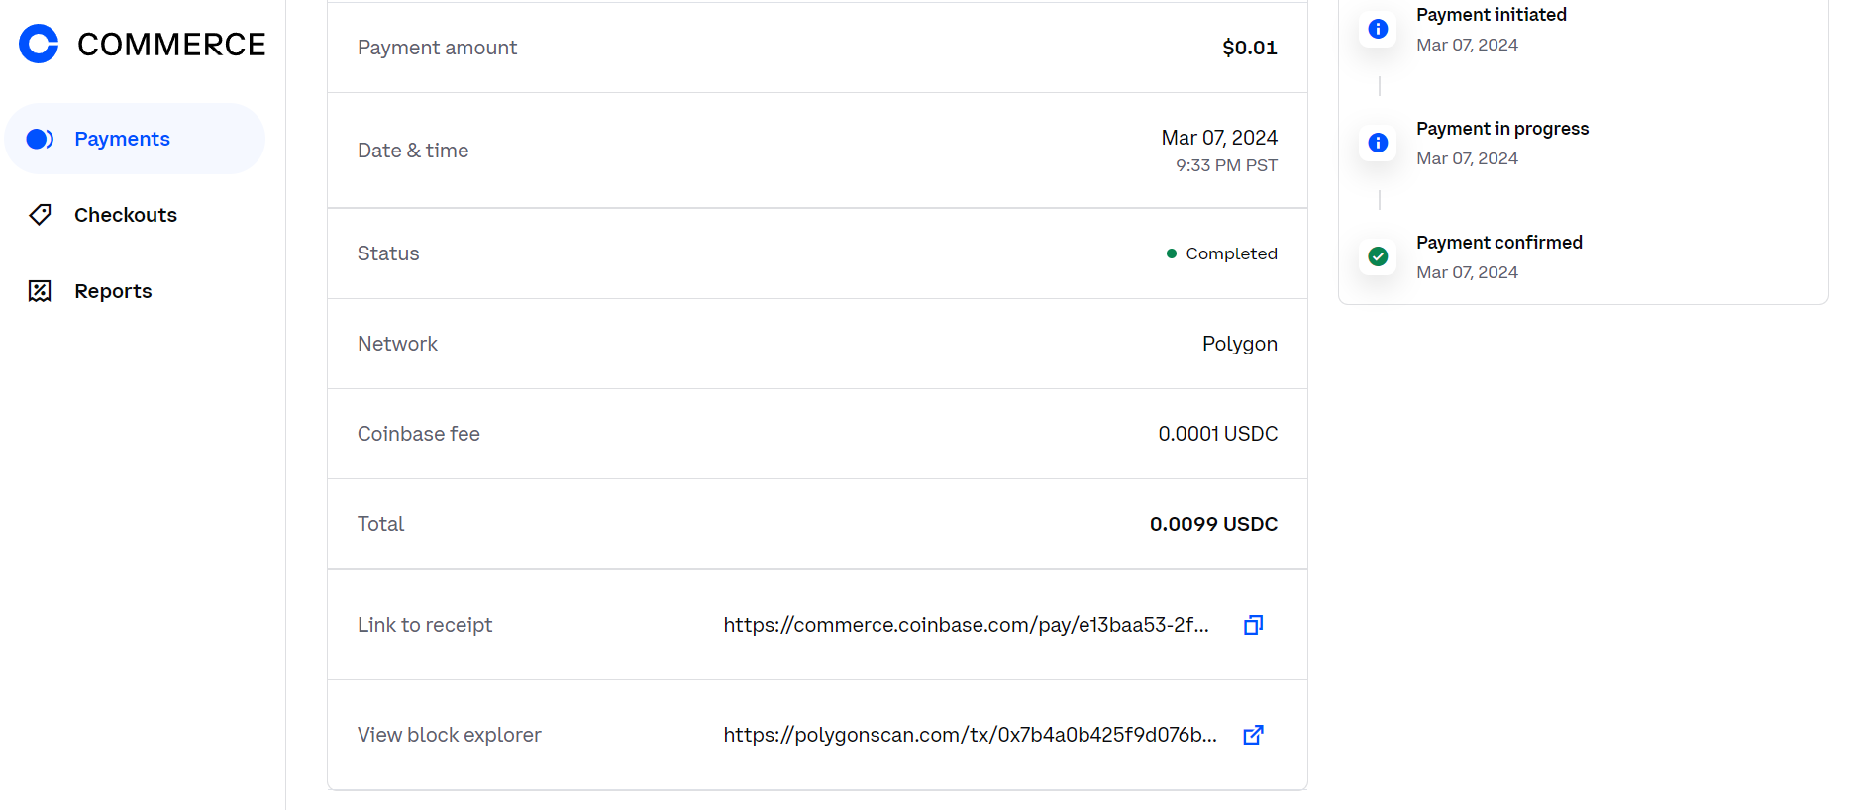

19)Link to the reciept is availabe to the doctor in the coinbase payments window

Reciept:

